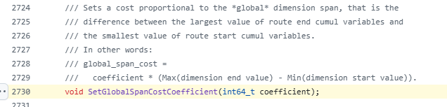
https://github.com/google/or-tools/blob/v9.4/ortools/constraint_solver/routing.h#L2730
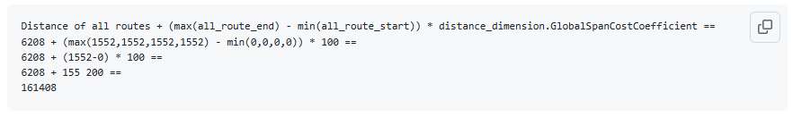
https://github.com/google/or-tools/discussions/3610

>> Set SetGlobalSpanCostCoefficient because we are doing restaurant deliveries

